TPS AGM 2009 REPORTS

President’s Report 2008/2009

As I come to the end of my two year stint as President it is pleasing to note the progress made in so many areas, detailed in the accompanying reports. Our Society seeks to look after the different interests of all our members. For locals we search out interesting displays and continue to improve the amenities of our table at “Tasmanian Stamp Auctions”. For our interstate and overseas members, whose interests are specifically Tasmanian we continue to build on our website, with a bulletin board and of course our journal, “The Courier”, published every six months.
Having recently visited Sydney and having experienced firsthand the philatelic dearth of its CBD I would suggest that we can count ourselves extremely fortunate to have, in Hobart, two excellent stamp dealers who actively support our activities. I have mentioned the support of Ross Ewington. Kim and David Newell of “The Stamp Place” in Trafalgar Place are the other key players. They provide discounts on stamp accessories and their shop acts as an exchange point for our circuit books. Moreover they host our public information board; an area which I suspect will receive increased attention in the coming months.
My sincere thanks then go to all our office bearers and committee members who have been instrumental in allowing the Society to reach its current position.

John Panckridge (President)

Secretary’s Report 2008/2009

Last year my Report started off with the words “This has been a year of significant changes”. These have continued!

The change to monthly meetings seems to have met with great acceptance since the doubling of average attendance, noted in last year’s Report, has continued and the enthusiasm of those attending has been evident. We have had many excellent exhibits from locals, guest speakers from interstate and our northern members. Speaking personally, I have seen material that I have only ever heard of and some that I didn’t know existed. Our monthly exhibits go from strength to strength.

The TPS website has also gone from strength to strength and the siting of facilities at the offices of Tasmanian Stamp Auctions has meant that they can be accessed at least five days a week instead of one evening a month. These facilities have been enhanced by the availability of a computer with excellent web access for the use of members. The site itself continues to expand with a place for articles and a bulletin board where anyone interested in Tasmanian stamps can meet with people of a like mind.

Once again, I would like to acknowledge the vigour and foresight of our President. He has continued to be instrumental in pushing forward the changes that have been so beneficial.

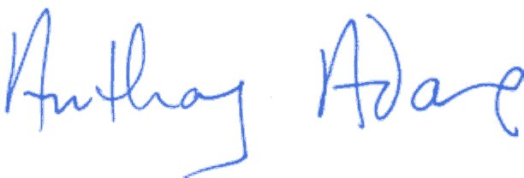

Tony Adams
Hon Secretary

